Draft Change request for Bi-mode Insulated Gate Transistor

CHANGE REQUEST
Request identity number: | C00292
Type of request: | Technically new
Request status level: | For evaluation
Proposal: | Standardize new graphical symbol for diagrams for representing concept of Bi-mode Insulated Gate Transistor.
Reason: | New semiconductor Bi-mode Insulated Gate Transistor (BIGT) was first presented at ISPSD conference in Barcelona in 2009.  Motivation: Customer request for correct graphical symbol for diagrams for integration in their circuit design schematics and simulation tools. IEC 60617 graphical symbols for IGBT (S00680, S00681, S00682, S00683) are not suitable for representing BIGT.
Requested by: | Hans Peter Leserf, Electrosuisse (CH NC)
--------------------------------------------------------------------------------------------------------------------

 | 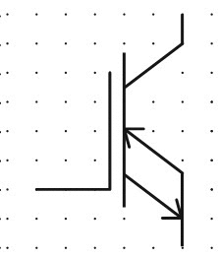
Identity number: | S01931
Name: | Bi-mode Insulated Gate Transistor
Status level: | Proposal
Alternative names: | Combined protective earthing conductor and line conductor
Applies: | S00624, S00625, S00627
Application class: | Circuit diagrams
Function class: | K Processing signals or information
Shape class: | Arrows, Lines
Keywords: | insulated gate, semiconductors, transistors
Change requests: | C00292

