Change Request on IEC 60617-S00044, follow up to C00135
Type of request: |  | Technical modification
Proposal: |  | An alternative name "Test terminal, twin stud type” should be added to S00044: Connecting link, closed in order to clarify a use of the symbol.
Reason: |  | S00044 is generally used as the symbol for a pair of terminals with a short-circuit bar in the electric power industry, which is called “test terminal.”  “Test terminal” is a stud type terminal on a front panel of the distribution and/or the control panel of a power plant and so on. It is inserted to the secondary circuit of an instrument transformer. When relays and meters connected to the secondary circuit of the instrument transformer is going to be calibrated and tested, they are separated from the secondary circuit by removing the short-circuit bar.
Drawing: |  | 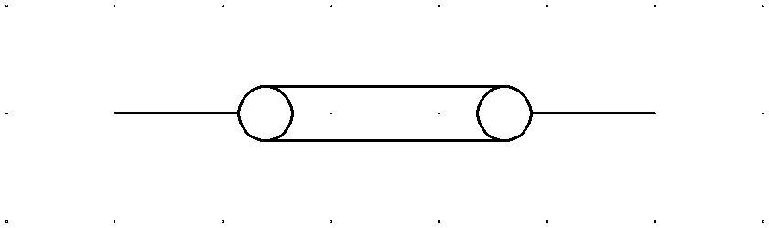
Description (temporary field) | EN
Description (temporary field) | FR
Name: | EN | Connecting link, closed
Name: | FR
Keywords: | EN | Connection devices, test terminals
Keywords: | FR
Form: | EN
Form: | FR
Remarks:
Application notes:
Alternative names: |  | Test terminal, twin stud type
Alternative forms: |  | S00045
Applied in:
Applies: |  | S00017
Source references:
Published in:
Entered on:
Evaluated on:
Released on:
Rejected on:
Obsolete on:
Proposed by: |  | JNC
Replaces:
Replaced by:
Application class: |  | Circuit diagrams, Connection diagrams, Function diagrams, Installation diagrams
Function class: |  | X Connecting
Shape class: |  | Circles, Depicting shapes
Symbol restrictions:

